Steps to run the project :

Prerequisite :

**Maven should be already installed for this project**

1. Install Eclipse as IDE for this project
2. Click on file and Import this project (Computer Database Example)
3. Go to Package Explorer and right click on this project (Computer Database Example) and select Run As Junit Test
4. To see the reports ,click on target folder and navigate to this folder

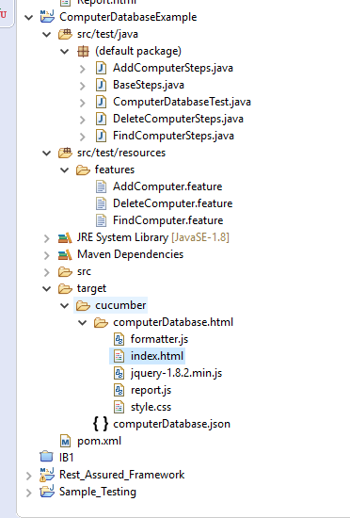

Right click on index.html

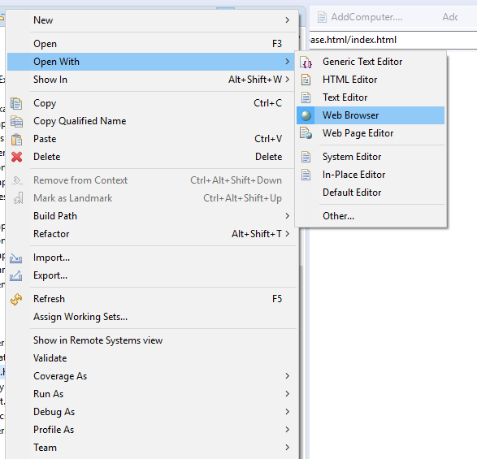

You will able to see reports of how many scenarios are passed

